# SIT107 – 8.3C

### Sprint 1 Demo & Presentation

### Tiffany Gray

### 218518691

### Gregory S McIntyre

### 218356779

#### Goal

The goal for our sprint was to create a network connected HR monitor, we would like to implement an SMS or email system, but this may be a future development

“As a user with a medical history of cardiac problems, I want a way to be able to determine if I have a regular heart rate and notify my emergency contacts if it becomes irregular.”

“As a designer I want to use a heart rate monitor as well as an ethernet board to make a network connected heart rate monitor that will notify emergency contacts if an irregular rhythm is determined.

#### Trello Link

<https://trello.com/b/O5xWVgtD/iot-hr-monitor>

#### GitHub Link for Burndown

<https://github.com/gregorymcintyre/SIT107-Team-Project-Sprint-1>

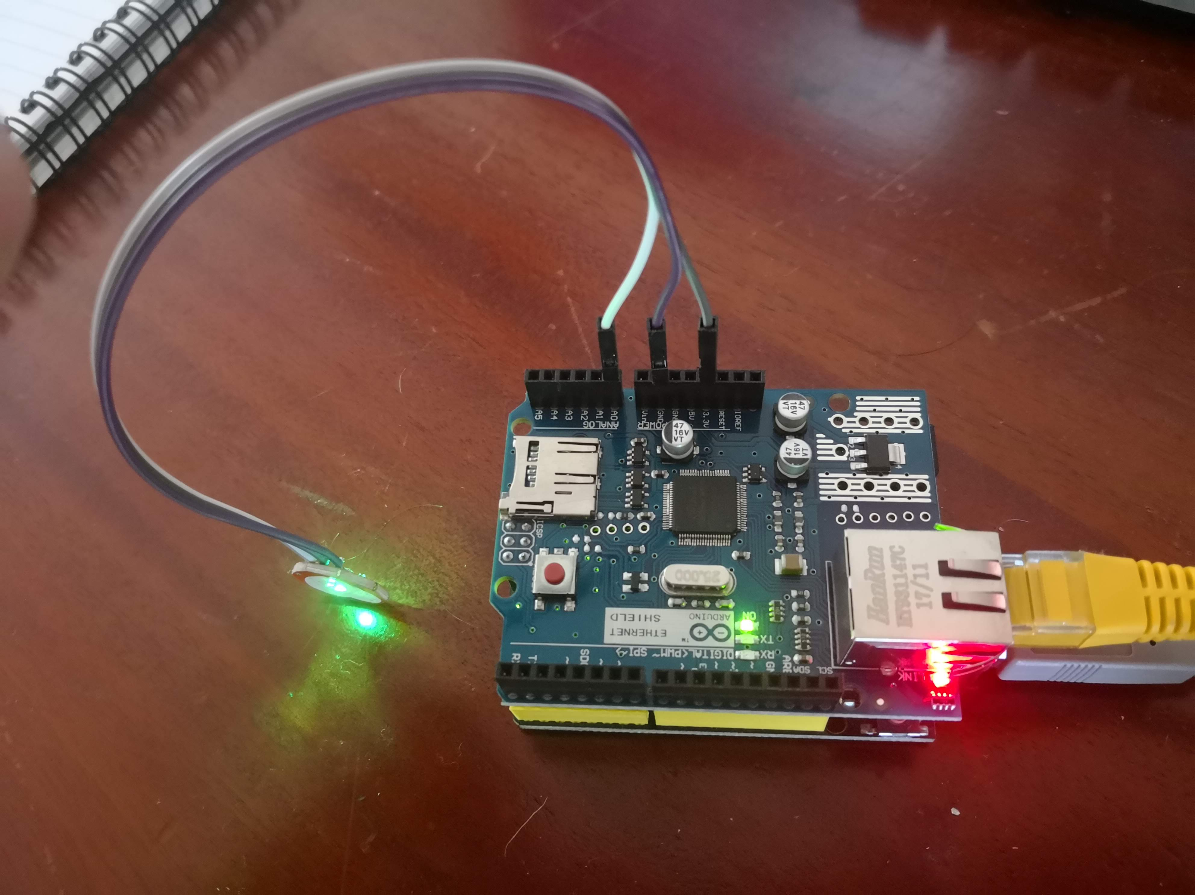

Figure 1: IOT HR monitor Prototype

### Presentation

For this project we decided to implement or ‘sense’ with the use of a Z6352 Heart rate monitor from <https://www.altronics.com.au/p/z6352-heart-rate-monitor-breakout-for-arduino/>, it is a cheap monitor and from experience they have a very short delivery time. It also made for a more interesting and challenging project. The heart rate came with no data sheet and had to be investigate by the whole team to better understand what data it was collecting in Figure 2: Z6352 Output, the serial plotter output can be seen. This was a much better way to visualise the data as the delay on the serial monitor gave only partial results and made it very difficult to understand the thresholds of the system.

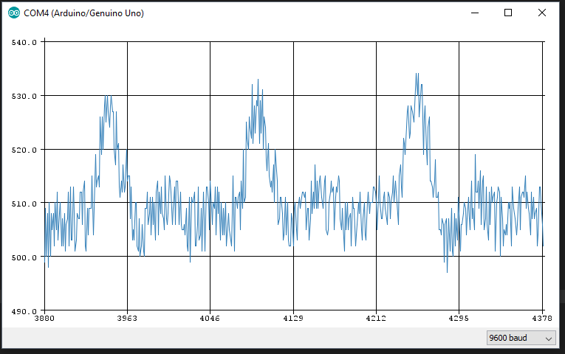

Figure 2: Z6352 Output

For the ‘Think’ we decided to use simple mathematics and the SimpleTimer library <https://github.com/schinken/SimpleTimer> this allowed us to keep track of samples over a set period of time using interrupts rather than adding a real-time clock. As can be seen from the sensor output the output from the HR monitor was an analog value between about 500 and 535. This may be variable depending on the user, but it was not tested. These upper and lower limits were used to create a Boolean variable as to avoid a switch bounce effect of over counting, these ‘peaks’ were added to an integer count and that count was multiplied to find the beats per minute (BPM).

When analysing this data, we keep to a simple HR guide of greater than 40 and lower than 220-minus age to find a normal range of variables. If the BPM was out of range it modified the HRIrreguar variable to show that the rate was not in normal range this would be our que to transmit an alert if the SMS or email system was operational, but for this version it just displays on the webserver output. The normal and irregular displays can be seen in

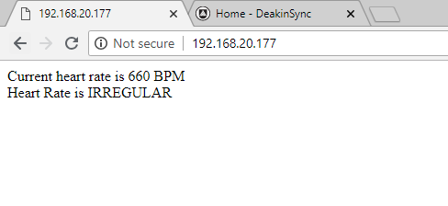

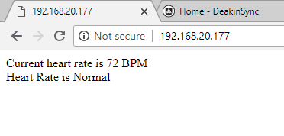

Figure 3: Web server output

##### Demonstration of the prototype.

<https://youtu.be/GurJD3HZfRs>

#### Group member roles/tasks.

**Tiffany Gray –** Sense, Presentation Design

**Greg McIntyre –** Act, Think

#### Challenges faced.

The initial version of the ‘Act’ Module involved using a C# module to take data from the COM port and send email. This version could not be made operational with the time restraints because the use of the Serial Monitor and the C# program caused a deadlock on the ports.

As spoken about earlier in the report there was initial problems with the pulse monitor, there was not data sheet, and this caused confusion as to what the sensor was feeding us, the sample rate and the COM port baud rate also added to the confusion as the number looked random as we were missing samples.